Introduction

In order to estimate the complexity, development time, and effort of our project, we adopted the COCOMO II (Constructive Cost Model II) method. COCOMO II is a widely recognized estimation model for software engineering that is used to calculate the expected effort in person-months and the development schedule in months.

For this project, the sizing method chosen is SLOC (Source Lines of Code). Since we had already computed the Function Points (FP), we converted them into SLOC. Specifically, the total 120 FP was translated into approximately 4,776 SLOC ( 4.776 quiniKSLOC ) :

80% backend services implemented in Node.js/Express (≈ 46 SLOC/FP)

20% frontend UI implemented in HTML/CSS/JavaScript (≈ 15 SLOC/FP)

This conversion allowed us to use COCOMO II with SLOC as the size input.
We used a COCOMO II tool available at softwarecost.org to calculate the estimated effort and schedule based on the provided SLOC, scale drivers, and cost drivers.

INPUTS
Sofware size:
Sizing method: SLOC
SLOC: 4,776
The SLOC value was obtained by converting the 109 Function Points estimated previously:
Backend (Node.js/Express): 80% × 120 FP × 46 SLOC/FP ≈ 4,416 SLOC
Frontend (HTML/CSS/JS): 20% × 120 FP × 15 SLOC/FP ≈ 360 SLOC
Total = 4,416 SLOC + 360 SLOC ≈ 4,776 SLOC

Scale Drivers :

Driver | Rating | Justification
PREC (Precedentedness) | Low | The team had no previous experience with a similar distributed medical project.
FLEX (Development Flexibility) | High | Requirements were defined by the course but allowed flexibility in implementation choices.
RESL (Architecture / Risk Resolution) | High | The architecture was clearly designed from the start using Docker microservices.
TEAM (Team Cohesion) | Very High | The team of three students worked closely together and coordinated effectively via Discord and GitHub.
PMAT (Process Maturity) | Low | The process was academic and agile-inspired.

Cost Drivers:

Product

Driver | Rating | Justification
RELY (Required Reliability) | Low | Academic setting.
DATA (Database Size) | Nominal | Moderate MongoDB use.
CPLX (Product Complexity) | Low | Mainly CRUD, authentication, messaging, and PDF generation.
RUSE (Required Reusability) | Low | Not designed for reuse in enterprise contexts.
DOCU (Documentation) | Nominal | Documentation at the level required by the course.

Driver | Rating | Justification
TIME (Execution Time Constraint) | Nominal | No strict performance constraints.
STOR (Main Storage Constraint): Nominal | Nominal | No critical memory or storage limitations.
PVOL (Platform Volatility) | Low | Stable technology stack (Node.js, MongoDB, Nginx).
Platform

Personnel
Driver | Rating | Justification
ACAP (Analyst Capability) | Low | Limited analyst experience as students.
PCAP (Programmer Capability) | Nominal | Solid programming skills.
PCON (Personnel Continuity) | High | Same team members throughout the project.
AEXP (Application Experience) | Low | First time working on healthcare/distributed systems.
PLEX (Platform Experience) | Low | First real use of Docker, MongoDB, and Node.js.
LTEX (Language and Tool Experience) | Nominal | Some prior knowledge of JavaScript and tools.

Project
Driver | Rating | Justification
TOOL (Use of Software Tools) | High | Extensive use of modern tools (Docker, GitHub, VS Code).
SITE (Multisite Development) | Nominal | Team worked remotely using Discord
SCED (Schedule Constraint) | Nominal | Fixed academic deadline.

Results
Based on the inputs described in Section 2, the COCOMO II Post-Architecture model produced the following estimation:

Computed Factors:
Effort Adjustment Factor (EAF): 0.79
Size Exponent (E): 1.0816
Schedule Exponent (F): 0.314
Estimation Outcomes:
Metric | Value
Effort (Person-Months) | 12.9
Schedule (months) | 8.1
Average staffing (people) | 1.6

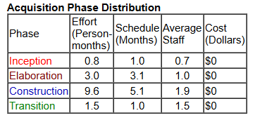

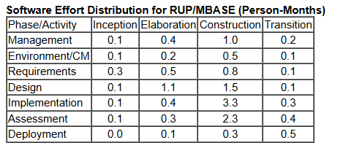

Comparison with Actual Project Data

The theoretical estimation produced by COCOMO II can be compared with the real effort and schedule experienced during the development of the project.
Actual Data:
Team size: 3 students
Project duration: 1 month
Effort: ≈ 3 Person-Months (3 people × 1 month)
Metric | Value
Effort (Person-Months) | 3.0
Schedule (months) | 1.0
Average staffing (people) | 3.0

